# Multiple File Renamer

Content

Multiple File Renamer 1

1. Software overview 2

2. Use 2

2.1 Rename files 2

2.1.1 Choose drive 2

2.1.2 Choose folder 3

2.1.3 Use filter 3

2.1.4 Choose files 4

2.1.5 Put in new file name 4

2.1.6 Press „Rename“-Button 5

2.2 Change standard language 5

2.3 Change language 5

2.4 View Infos 5

2.5 View license 5

2.6 View homepage 5

2.7 Shortcuts 5

3.Impressum 6

## 1. Software overview

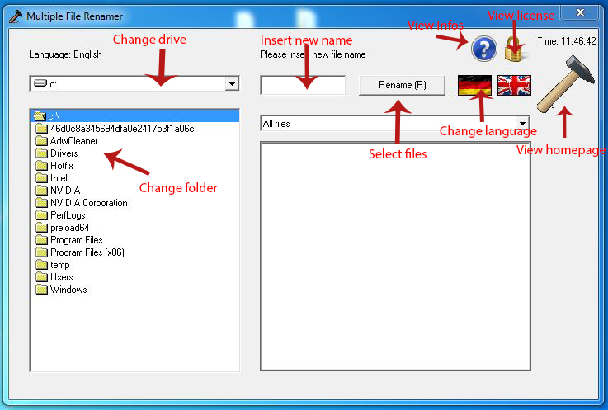

The Multiple File Renamer is a software to quickly rename multiple files.

## 2. Use

### 2.1 Rename files

#### 2.1.1 Choose drive

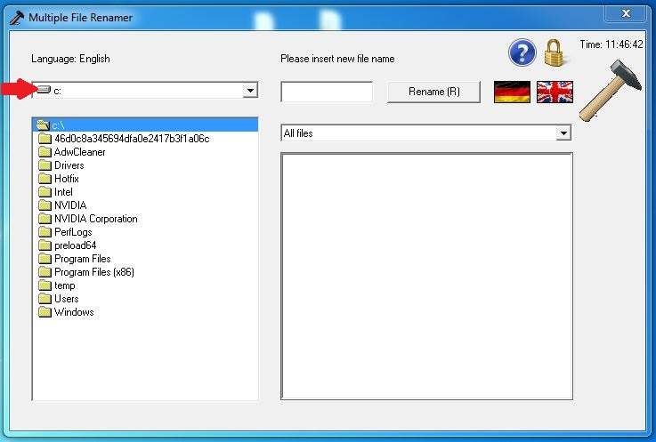

#### 2.1.2 Choose folder

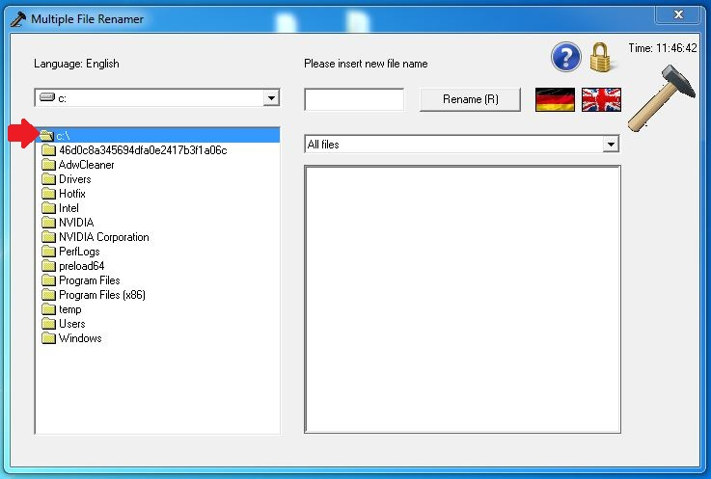

#### 2.1.3 Use filter

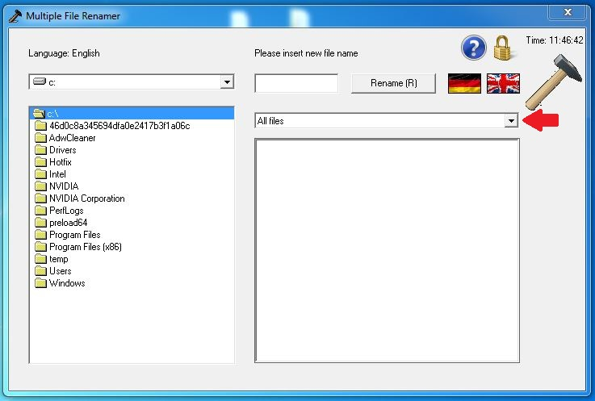

#### 2.1.4 Choose files

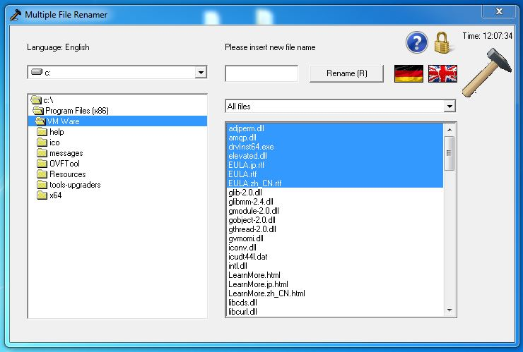

#### 2.1.5 Put in new file name

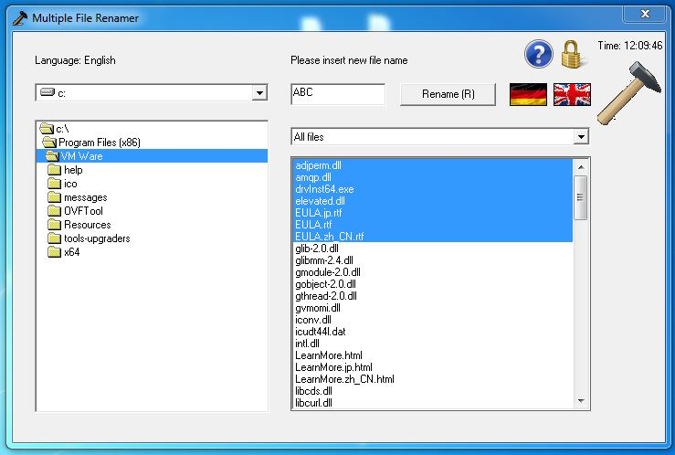

#### 2.1.6 Press „Rename“-Button

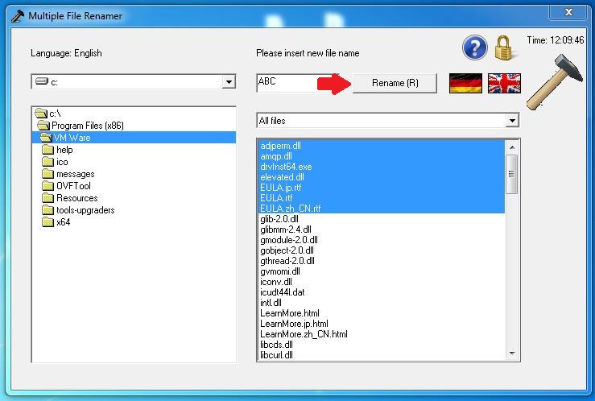

### 2.2 Change standard language

Set the „+“ in front of "ENG" and remove it from "+Ger"

### 2.3 Change language

View 1.

### 2.4 View Infos

View 1.

### 2.5 View license

View 1.

### 2.6 View homepage

View 1.

### 2.7 Shortcuts

**With German language:**

Alt+U ≙ Rename

Alt+S ≙ Change language

**With English language:**

Alt+R ≙ Rename

Alt+L ≙ Change language

## 3.Impressum

Product: MultipleFileRenamer

Product version: 1.0.11

Company: Hämmer Electronics GmbH

Copyright: ©opyright @Hämmer Electronics GmbH®

Trademarks: MultipleFileRenamer©, Hämmer Electronics GmbH®

Developer: Tim Hammer

License: Public